<https://robojax.com/learn/arduino/?vid=robojax_ESP32_camera>

**How to setup ESP32 Camera using Arduino IDE and Arduino UNO**

The link to use in the "preferences" of Arduino IDE for ESP32 board <https://dl.espressif.com/dl/package_esp32_index.json>

**How to change the default ESP32 camera resolution?**

To change the resolution, change this **FRAMESIZE_UXGA** variable in the current code to one of the followign value for required resolution:

* FRAMESIZE_QVGA for 320x240
* FRAMESIZE_CIF for 400c296
* FRAMESIZE_VGA for 640x480
* FRAMESIZE_SVGA for 800x600
* FRAMESIZE_XGA for 1024x768
* FRAMESIZE_SXGA for 1280x1024
* FRAMESIZE_UXGA for 1600x1200

------------------------------------------------------------------------------------------------

<https://www.edgoad.com/2021/02/programming-esp32cam-using-arduino-uno.html>

# Programming ESP32CAM using Arduino Uno

POSTED [FEBRUARY 18, 2021](https://www.edgoad.com/2021/02/programming-esp32cam-using-arduino-uno.html) [ED GOAD](https://www.edgoad.com/author/edgoad)

## Add ESP32 to Arduino IDE

1. Open the Arduino IDE
2. Go to **File | Preferences**
   * In the **Additional Boards Manager URLs** field, add the following 2 URLS separated with a comma:
   * https://dl.espressif.com/dl/package_esp32_index.json, http://arduino.esp8266.com/stable/package_esp8266com_index.json
   * Click **OK**
3. Go to **Tools | Board | Boards Manager**
   * In the **Filter your search** bar, enter ESP32
   * Select **esp32** by **Espressif Systems** and click **Install**
   * Once installed, click **Close**
4. Go to **Tools | Board | ESP32 Arduino** and select **ESP32 Wrover Module**

## Open Camera sample sketch

Once the ESP32 board is loaded into the IDE, now we can load the sample camera sketch to test the board.

1. Begin by attaching the Arduino UNO to your computer
2. In the IDE, go to **File | Examples | ESP32 | Camera | CameraWebServer**
3. At the beginning where it says **Select camera model**
   * Add a comment (double forward slash) in front of the line #define CAMERA_MODEL_WROVER_KIT
   * Uncomment the line #define CAMERA_MODEL_AI_THINKER
   * **NOTE:** The model may be different depending on where and when you purchase your version
4. Add the **SSID**and **Password**for your WIFI
5. On the **Tools**menu, make sure you have the following selected:
6. FlashMode: **QIO**
   * Partition Scheme: **Huge App (3MB…**
   * Flash Frequency: **40MHz**
   * Upload Speed: **115200**
   * Port: **Arduino Uno**
   * Programmer: **AVR ISP**
   * **NOTE:** This last last option wasn’t available for me and worked without a programmer set. I am leaving it here because it was in the initial instructions

## Upload sketch

Once the UNOand ESP32cam are connected and the sketch is ready, we can upload the code.

1. In the Arduino IDE, click **Upload**
2. Watch the black window at the bottom until it says **Connecting**
3. On the ESP32cam, click the **Reset**button once and wait
4. The upload will take about 1 minute
   * NOTE: If this step fails for some reason, disconnect the USB cable from the UNO, reconnect it, and restart the Upload
5. When the upload is finished, select **Tools | Serial Monitor**
6. Ensure the speed is set to **115200**
7. On the ESP32cam disconnect the cable between **GPIO 0 and GND** and click the **Reset**button
8. Watch the **Serial Monitor** for the IP address of the ESP32
   * If you missed the IP address in the output, clicking the Reset button will restart the ESP32cam module and will reprint the address

ets Jun 8 2016 00:22:57

rst:0x1 (POWERON_RESET),boot:0x13 (SPI_FAST_FLASH_BOOT)

flash read err, 1000

ets_main.c 371

ets Jun 8 2016 00:22:57

rst:0x1 (POWERON_RESET),boot:0x13 (SPI_FAST_FLASH_BOOT)

flash read err, 1000

ets_main.c 371

ets Jun 8 2016 00:22:57

rst:0x10 (RTCWDT_RTC_RESET),boot:0x13 (SPI_FAST_FLASH_BOOT)

configsip: 0, SPIWP:0xee

clk_drv:0x00,q_drv:0x00,d_drv:0x00,cs0_drv:0x00,hd_drv:0x00,wp_drv:0x00

mode:DIO, clock div:2

load:0x3fff0018,len:4

load:0x3fff001c,len:1216

ho 0 tail 12 room 4

load:0x40078000,len:10944

load:0x40080400,len:6360

entry 0x400806b4

ets Jun 8 2016 00:22:57

rst:0x1 (POWERON_RESET),boot:0x13 (SPI_FAST_FLASH_BOOT)

flash read err, 1000

ets_main.c 371

ets Jun 8 2016 00:22:57

rst:0x10 (RTCWDT_RTC_RESET),boot:0x13 (SPI_FAST_FLASH_BOOT)

configsip: 0, SPIWP:0xee

clk_drv:0x00,q_drv:0x00,d_drv:0x00,cs0_drv:0x00,hd_drv:0x00,wp_drv:0x00

mode:DIO, clock div:2

load:0x3fff0018,len:4

load:0x3fff001c,len:1216

ho 0 tail 12 room 4

load:0x40078000,len:10944

load:0x40080400,len:6360

entry 0x400806b4

.....

WiFi connected

Starting web server on port: '80'

Starting stream server on port: '81'

Camera Ready! Use 'http://192.168.1.243' to connect

---------------------------------------------------------------------------------------------------------------

<https://technoreview85.com/how-to-program-esp-32-cam-using-arduino-uno-board/>

### Connection ESP32 cam to Arduino UNO

* Connect Arduino 5volt to esp 32 cam 5 volt.
* Arduino GND to GND
* Arduino RX to Cam board RX & TX to TX
* Arduino reset pin to GND
* ESP 32cam D0 to Gnd

**Make sure the cam board DO is connected to gnd. It will enable esp 32 flash mode otherwise you can’t program it. after compleat, the programming remove D0 to gnd**

Now open Arduino IDE on your PC, go to File > Preferences >

Now paste below link in the board manager URL

https://dl.espressif.com/dl/package_esp32_index.json

esp32ca programming

Now go to Tools > Board > Board manager > & search for ESP 32

You can see esp 32 board Download & install the latest version package

After complete, the installation go to Tools > Select port where arduino UNO is connected

* Now go to board > select board > ESP32 ” Wrover Module”
* Flash Mode > QIO
* Flash Frequency > 40MHZ
* Partition Scheme > Huge App (3mb No OTA)
* Upload speed > 115200
* Programmer > AVR ISP

Now it is ready for uploading sketch

You can test it Go to File > Example > ESP32 > Camera > Camera web server and upload the sample sketch

------------------------------------------------------------------

<https://www.electroniclinic.com/esp32-cam-esp32-camera-programming-using-arduino-issues-fixed/>

## **ESP32 connection with Arduino Uno**

Connect the Reset Pin of the Arduino with the GND.

Connect the 100 pin of the ESP32 Cam with the GND Pin, for this you can use a female to female type jumper wire.

Connect the 5V and GND pins of the ESP32 Cam with the Arduino’s 5V and Ground.

Connect the Receive Pin of the ESP32 Cam with the RX pin of the Arduino.

Connect the Transmit Pin of the ESP32 Cam with the TX pin of the Arduino.

The ESP32 Cam interfacing with the Arduino is completed. Now, let’s go to the computer screen and install the ESP32 Cam board.

## **ESP32-Cam Board Manager Installation:**

Make sure the latest version of the Arduino IDE is installed on your computer. Copy the link given below.

https://raw.githubusercontent.com/espressif/arduino-esp32/gh-pages/package_esp32_index.json

Now, open the Arduino IDE, click on the file menu and then click on the preferences and simply paste the URL.

[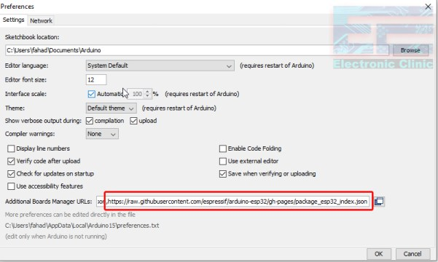](https://i0.wp.com/www.electroniclinic.com/wp-content/uploads/2020/07/esp32-cam-url-link-in-arduino-ide.jpg?ssl=1)

Now click on the Tools menu, boards, and click on the boards manager, search for the ESP32 and install, this can take several minutes. Next check if the desired board is installed,

[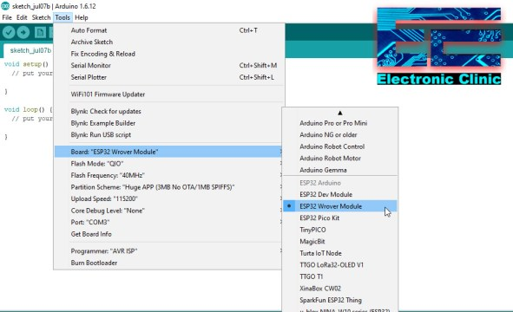](https://i2.wp.com/www.electroniclinic.com/wp-content/uploads/2020/07/ESP32-Wrover-Module-installed.jpg?ssl=1)

As you can see the ESP32 Wrover Module is available.

## **ESP32 Cam Settings:**

Next, go to the Flash Mode and select QIO.

Next, select the Flash Frequency as the “40Mhz”

Next, Select the Partition Scheme as the Huge APP.

Next, Select 115200 as the Upload Speed and Finally

Select the Programmer “AVR ISP”

As you can see Port: “COM3”, this means that the Arduino board is connected with the Laptop through a USB Cable.

Click on the File Menu > Examples > ESP32 > Camera > CameraWebServer

Open the CameraWebServer Program.

Next, enter your SSID and password.

Select your Camera Model.

[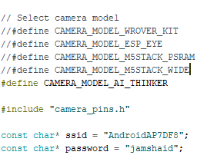](https://i1.wp.com/www.electroniclinic.com/wp-content/uploads/2020/07/esp32-camera-model-and-ssid-and-password.png?ssl=1)

We are all set, now we can click on the upload button.

Now the next step is to remove the wire that we used to short the IO0 pin and ground.

==========================================================

<https://dronebotworkshop.com/esp32-cam-intro/>

Another thing missing from the ESP32-CAM module is a USB port.  In order to program this device you’ll need to make use of an FTDI adapter. This will be described further on in this article.

https://dronebotworkshop.com/esp32-intro/

https://easyelectronicsproject.com/esp32-projects/program-esp32cam-arduino/

https://technoreview85.com/how-to-program-esp-32-cam-using-arduino-uno-board/

https://www.edgoad.com/2021/02/programming-esp32cam-using-arduino-uno.html

https://www.iotstarters.com/esp32-cam-code-upload-using-arduino-uno/

https://www.nutsvolts.com/magazine/article/build-a-video-camera-using-the-esp32-cam-board

https://randomnerdtutorials.com/solved-failed-to-connect-to-esp32-timed-out-waiting-for-packet-header/

Holding the BOOT/FLASH button

One of the ways to solve this is holding-down the “BOOT/FLASH” button in your ESP32 board while uploading a new sketch at the same time. But having to worry about this every time you want to upload new code can be tedious, specially when you’re testing and debugging your code.

serial monitor: 115200 baud

http://www.hiletgo.com/ProductDetail/2152064.html

Specifications:

USB power has over current protection, using 500MA self-restore fuse.

RXD/TXD transceiver communication indicator.

Pitch:2.54mm.

Please download the driver and files at link:

http://www.ftdichip.com/FTDrivers.htm

PLEASE NOTE – When editing driver INF files, refer to the following document: AN_107 – Advanced Driver Options

https://ftdichip.com/wp-content/uploads/2020/07/AN_107_AdvancedDriverOptions_AN_000073.pdf

https://ftdichip.com/wp-content/uploads/2021/08/CDM212364_Setup.zip

New drivers are now available to support the FT4222H – for D2XX drivers please click here.

Windows Driver Installer (VCP & D2XX), please click here.

Note:

This adapter is not genuine FTDI chip because it's based on so cheap a price, so it will be automatically bricked by the latest FTDI drivers in Windows.The fix is to ensure that you use the older version of the FTDI drivers (2.8.3) on windows or use only with Linux or OS X. If you've already bricked it, please follow these instructions at below link (requires a Debian based Linux

http://www.minipwner.com/index.php/unbrickftdi000

ov7670 arduino camera sensor

https://robojax.com/learn/arduino/?vid=robojax_ESP32_camera

How to setup ESP32 Camera using Arduino IDE and Arduino UNO